Tech Nest Academy:
AWS-Syllabus

🧑‍🏫 Course Name: AWS Data Engineering
Duration: 30 Days (Approx. 2 Months)
Fees: ₹20,000{Rs.17000 for the students of Tech Nest Academy}
Includes: 3 real-time projects, Resume building, Mock Interviews, Certificate assistance
Class schedule: Mon,Tue,Thur & Fri [7-9pm IST]
Trainer: Velmurugan-15 years of Exp

📅 Day-wise Topics
🗓️ Week 1: AWS & Big Data Basics
• 🧠 Day 1: Cloud Computing, AWS Basics, Serverless, Data Engineering on AWS
• 🔐 Day 2: IAM Users & Roles, AWS S3, Local Dev Setup, S3 CLI
• 🧰 Day 3: Common AWS Services, Intro to Boto3
• ⚙️ Day 4: Spark Architecture
• 🏢 Day 5: OLAP vs OLTP, Data Warehousing Concepts
• 🔄 Day 6: RDD vs DataFrame Fundamentals
• 🧪 Day 7: PySpark Transformations & Actions

🧩 Week 2: AWS Glue & PySpark
• 🏗️ Day 8: AWS Glue Architecture, Job Scripts
• 🤖 Day 9: Boto3 Automation
• 📚 Day 10: Glue Data Catalog, Databases
• 🚀 Day 11–12: Project 1 – ETL with RDS/DynamoDB & Glue
• 🧵 Day 13: Glue Workflow Orchestration
• 🔍 Day 14: CTEs, Spark Complex DataTypes, Git Integration
• 🧠 Day 15–17: Spark Partitions, UI, Optimization (Join Strategy, AQE, Data Skew)

🌊 Week 3: Lakehouse & Orchestration
• 🏞️ Day 18: Lakehouse Architecture, Apache Iceberg
• 📊 Day 19: Iceberg SQL, Metadata Mgmt, SCD Type 2
• 🪝 Day 20–21: Lambda, S3, DynamoDB, SNS, Transfer Family (SFTP)
• 🔄 Day 22: AWS Step Functions
• 🎯 Day 23–24: Project 2 – Event-Driven Pipelines with Orchestration & Alerts

❄️ Week 4: Snowflake & Streaming
• 🧊 Day 25: Snowflake Architecture, Trial Setup
• 📦 Day 26: Tables, Staging, Ingestion (S3, Azure Blob), CTEs
• 🧬 Day 27: Snowspark, Semi-structured Data (JSON, VARIANT)
• ⏪ Day 28: Time Travel, Zero-Copy Cloning, Streams & Tasks
• 📡 Day 29: Project 3 – Streaming Pipeline (Snowpipe + Firehose)
• 🧱 Day 30: Medallion Architecture, Final SCD Implementation

🔧 Tools & Technologies
• ☁️ AWS: S3, Glue, Lambda, IAM, RDS, DynamoDB, Step Functions, EventBridge
• ⚡ Spark (PySpark)
• 🧊 Apache Iceberg
• ❄️ Snowflake
• 🧬 Git
• 🐍 Boto3
• 💻 AWS CLI

🎁 Bonus Sessions
- 📄 Resume Building Assistance
- 🎤 Mock Interview Sessions
- 🧑‍💼 Job Profile Optimization
- 🎞️ Lifetime Access to Course Recordings
- ❓ 50+ Company Interview Questions

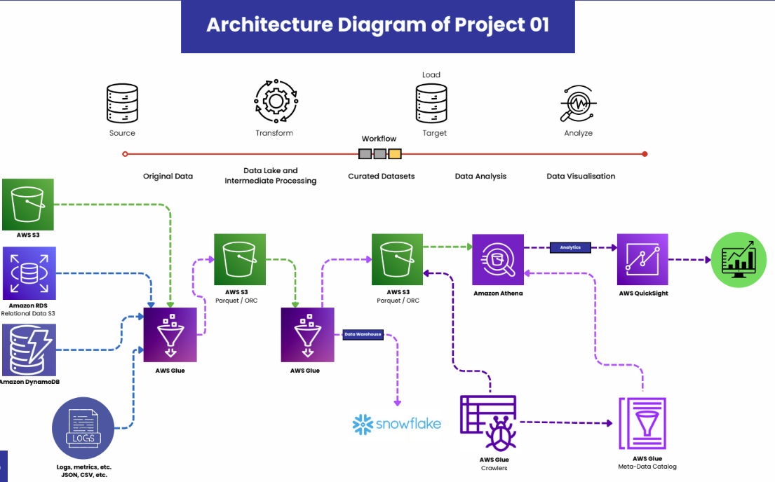

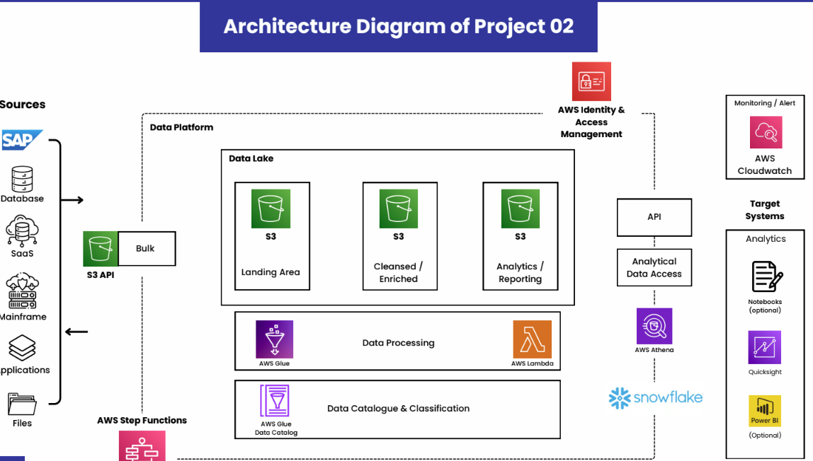

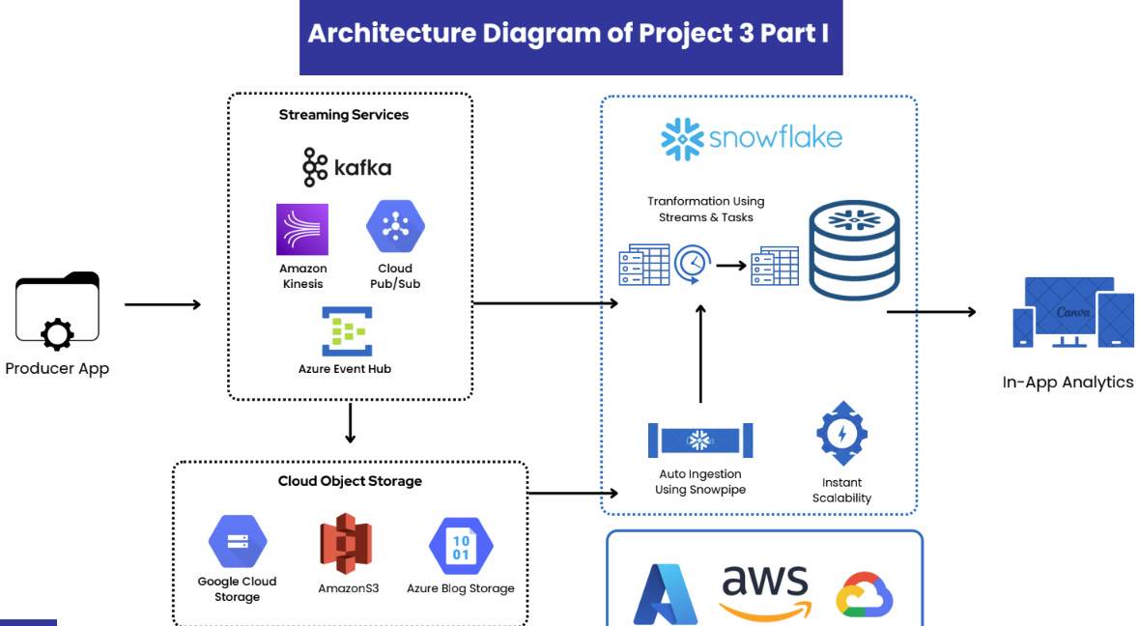

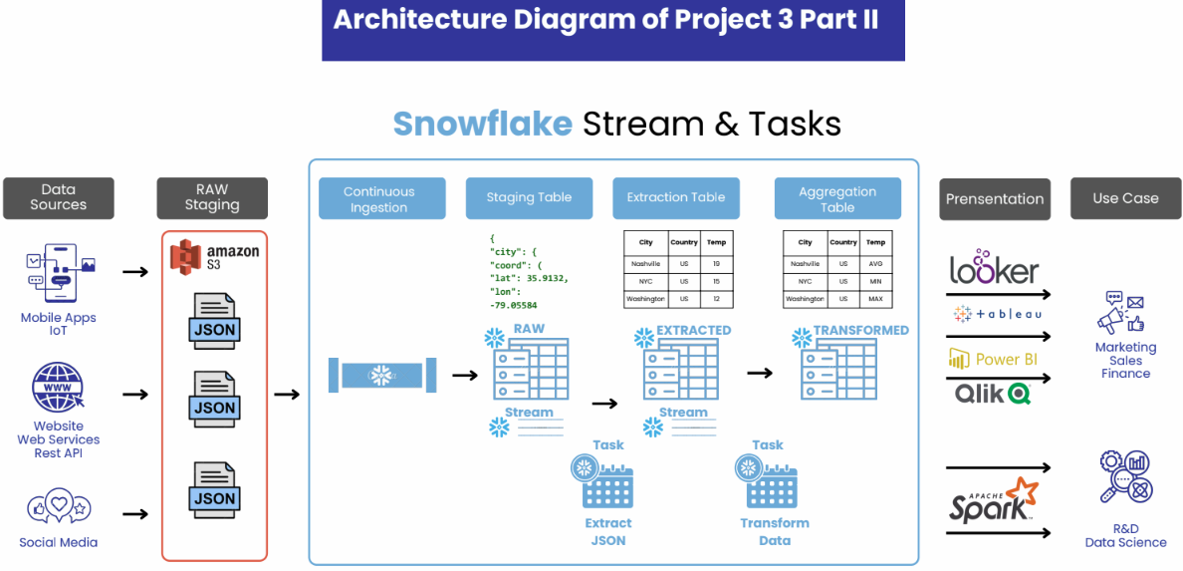
***************************End*************************

